DMES Parents –

In our November newsletter, I wrote to you about our focus on the academic performance of your children. They are capable, and we aspire to work with you to help them reach their potential. I told you that the DMES faculty was drafting some skills that your child should be able to master at each grade. This is our first draft:

Grade Level | Skills
K5 | - Write their first and last name from memory  - Name all 26 uppercase and 26 lowercase letters  - Form all 26 letter sounds  - Read 25 sight words  - Orally Count 1-100  - Orally Count by 10’s to 100  - Name and write numbers 0-20
1st | - Write and identify numbers to 120  - Add fluently up to 10  - Subtract fluently up to 10  - Read 100 high frequency words  - Given a prompt, write a story meeting grade level expectations.
2nd | - Add fluently up to 20  - Subtract fluently up to 20  - Add with regrouping  - Subtract with regrouping  - Read 50 sight words  - Given a prompt, write a story that meets grade level expectations.
3rd | - Multiply fluently through 11s  - Given a prompt, write a passage that meets grade level expectations.  - Demonstrate reading comprehension on a grade level appropriate passage.
4th | - Multiply fluently through 12s.  - Given a prompt, write a passage that meets grade level expectations.  - Demonstrate reading comprehension on a grade level appropriate passage.
5th | - Simplify fractions  - Solve division problems with two-digit divisors  - Given a prompt, write a passage that meets grade level expectations.  - Demonstrate reading comprehension on a grade level appropriate passage.

As we design our final draft, we would like your feedback. See if your child is able to do the things we’ve listed at his/her grade level, speak with your child’s teacher about how these might be assessed, and, by January 7, email feedback to me at twebster@spart7.org.

(please see other side)
I would like to once again encourage you to speak with your child’s 1st-5th grade teacher to know what your child’s Fall MAP score was and set a goal for January’s Winter MAP. These are the grade level expectations:

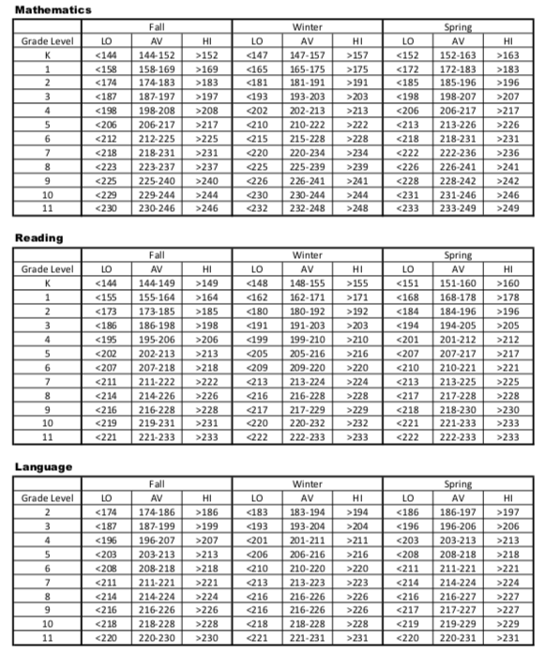

I am confident that, with us all working together, our children can meet and exceed their goals!

Thomas Webster
Principal, Drayton Mills Elementary School
twebster@spart7.org

